**SCHOOL OF COMPUTING**

**UNIVERSITY OF TEESSIDE**

**MIDDLESBROUGH**

**TS1 3BA**

**Multimodal Interfaces for Games (COM2061)**

**ICA Component 2  
Graphical User Interface for a Games Tool**

**Michael Thomas**

**S6099298**

**10/01/2018**

Table of Contents

1 Introduction 3

2 Software Design 4

3 Results 5

4 Conclusion 6

5 REFERENCES/BIBLIOGRAPHY 7

# Introduction

ADD WHAT LAB I TESTED THE EDITOR IN E.G. OL9

My game editor was designed for users to easily create their levels for their game by loading in their sprite sheet and start designing their level. Below is an example of what my level editor was aiming for with a terraria style game and others like Super Mario Bros. Once the user creates their level they can then save their level as an XML and use it in their game, also the xml file can be loaded back into the level editor if the user wants to edit their level.

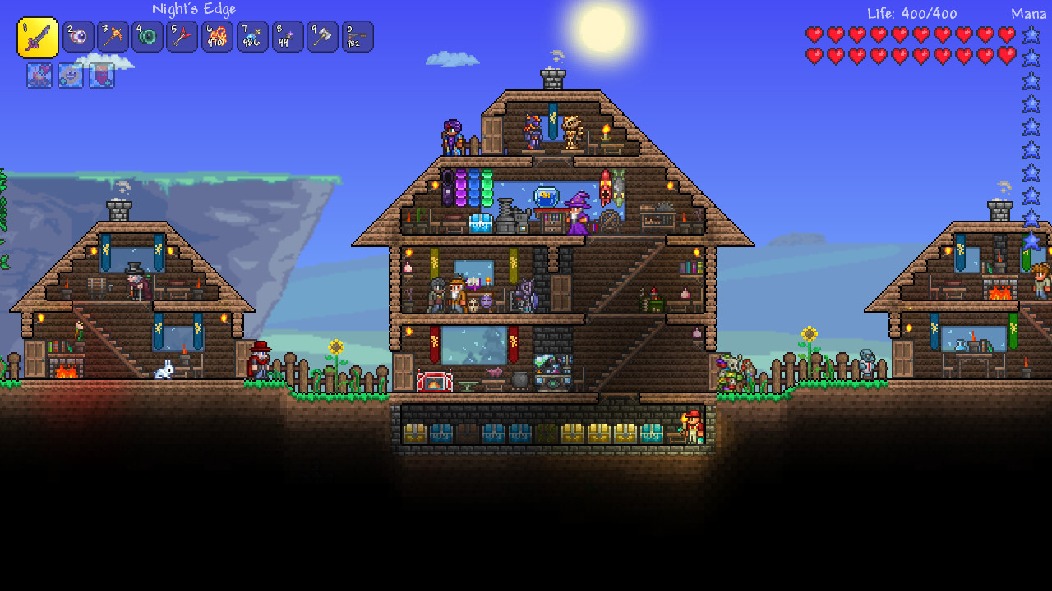

# Software Design

Onto the software design, the game editor has the essential features needed for a game editor such as: load (PNG) sprite sheets which is 32x32 sprite sheets, also the user can set the tile they want and draw it onto the screen. The game editor has 3 layers so you can have a background layer and the other 2 layers could be used to create things like buildings, also the editor has collision and allows the user to set collision for certain tiles such as walls, building etc. Another good feature I added was the ability to toggle layers to visible to invisible by tick boxes, which all layers are set to be visible by default when the editor is opened, so the user can keep track of what layer they are on and make layers invisible when they are done with that layer. There is also an eraser feature that you can use by clicking the eraser icon to delete tiles on the canvas on a specific layer which is very good in case you make mistakes and want to delete a tile you didn’t mean to place. Other features are the clear function which is located at the top on the toolbar that allows the user to completely wipe the canvas clean if they want to start over, also there is an exit function that is also on the toolbar that you can click which will close the editor. Lastly is the ability to change the canvas size while in the editor by changing the height and width located under the tile sheet.



Exit Application

Clear Canvas

Delete

Draw

Save as XML file

Load XML file

Load PNG file

Above/below are two screenshots of the user interface components I decided to go for with the game editor. Firstly, the toolbar with the icons, which is at the top of the editor when the editor is opened so the user can easily find the toolbar. I decided to go for a simplistic look so the user can easily understand and navigate the editor easily, so the first icon indicates that it is a picture and when you click the icon it opens a dialog box so you can select your PNG file to be loaded in. The next icon is used to load a xml file into the editor such as XML-based files you have created from the editor and want to load it back in. The next icon is very easy to understand which is to save to a XML-based file such as completing the design of a level and saving it as a XML-based file to use in a game. The pencil and eraser icons are toggles that can be toggle between each other so the pencil allows you to draw your tiles onto the canvas whereas when you click on the eraser it allows you to remove tiles on the canvas such as misplacing tiles. The last two icons are the blank page which when click clears the canvas completely so you user can start over again if they wish to do so. Now the other icon is the exit icon, which simply when clicked closes the program, so the user needs to make sure they save their level editor before they close the application!

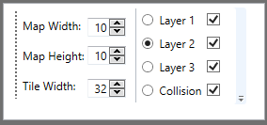

This screenshot above shows the user interface options for the canvas such as changing the map width and height whenever you want so the user is not limited to a certain width and height when they decide to create their level. The tile width is set at 32 and currently only supports 32x32 tile sheets. Onto the layers which in the screenshot above shows which layer you are currently on which is layer 2 and you can change between which layer you want, but also the tick box next to the layers and collision allow you to make layers invisible/visible for example when you set all the collision it shows a transparent red box over the tile but can be distracting when still creating the rest of the level so you can untick the box and the collision layer will be made invisible but don’t worry all layers are saved even if all the layers are unticked.

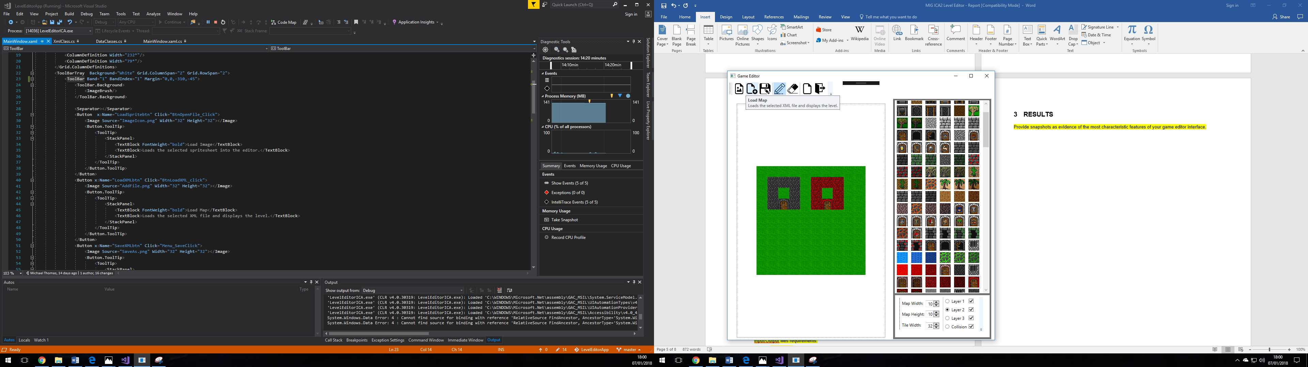

All the icons when hovered over displays a brief description of what that button does, to help the user learn what each button does.

# Results

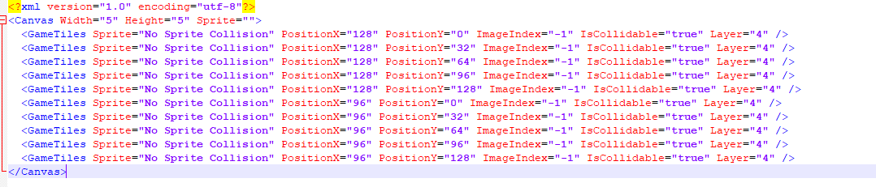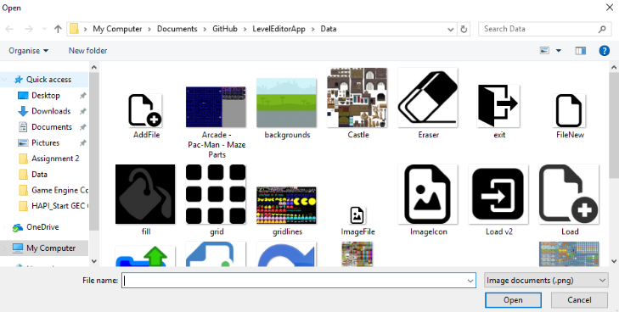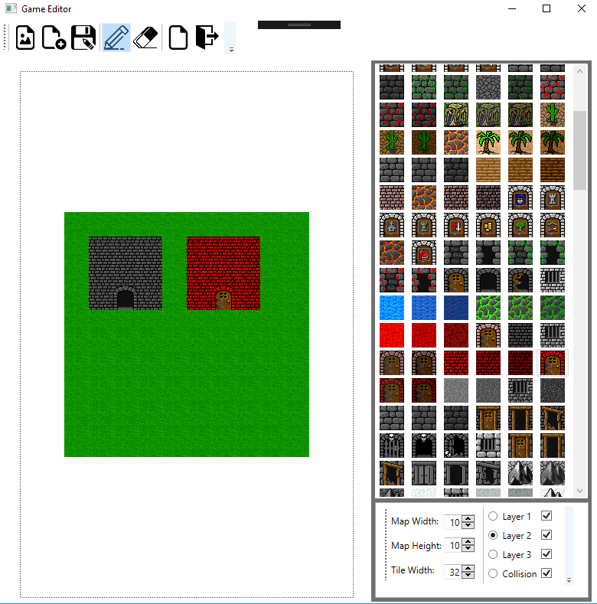

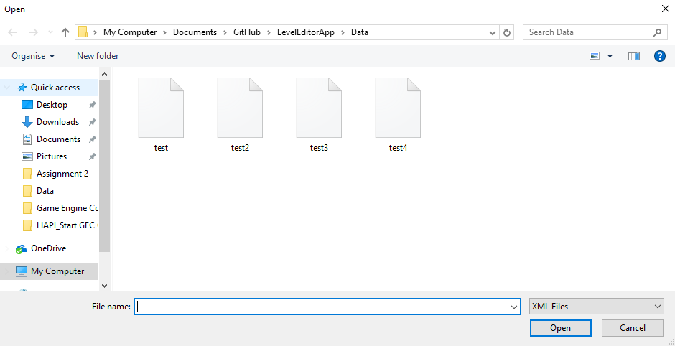

Above shows the whole game editor in action with two building created and the grass as its own layer, all the features of the icons to the toolbar below the tiles are all designed to be user friendly and be very easy for anybody to pick up and understand with tooltips for the icons when hovered over for users who don’t quite understand what each button does. All these characteristic features make the it very hassle free for the user since with this screenshot all the features are all displayed on the screen and one click away, whereas user interfaces with menus can be difficult to use such as having to open menu after menu to find the feature you’re looking for. This game editor is made/designed for instant access of features and to be able to create your own professional editor in matter of minutes. Also, the friendly feature of file dialog boxes that open when you want to load(PNG/XML) files into the editor or save as XML- based files to be used elsewhere. Lastly you can see the content inside a XML which each game tile contains a location to the tile sheet, the position so you know where you the tile will be positioned in the game, the image index is also stored so you can load in the correct image index of the sprite sheet into your game. Also, there is collidable which is stored so the you know what tiles are collidable and what tiles aren’t. Lastly is the layer it was set on which is also stored in the XML file for user to use in their game.

# Conclusion

Overall, I feel my game editor is a good success and achieving a very good simplistic GUI design to create levels for games and the GUI doesn’t hinder the user from their ability to create their levels effortlessly. So, to conclude I feel my game editor achieved all the needed features for a game editor with extra features such as eraser, change map size and layers to help the user even more to create their perfect level.

# REFERENCES/BIBLIOGRAPHY

<https://icons8.com/icon/1393/image-file> - PNG image file icon

<https://icons8.com/icon/358/save-as> - Save as icon

<https://icons8.com/icon/55/file> - New icon

<https://icons8.com/icon/496/add-file> - Add XML image icon

<https://www.flaticon.com/free-icon/exit_24069> - Exit icon

<https://thenounproject.com/term/eraser/3715/> - Eraser icon